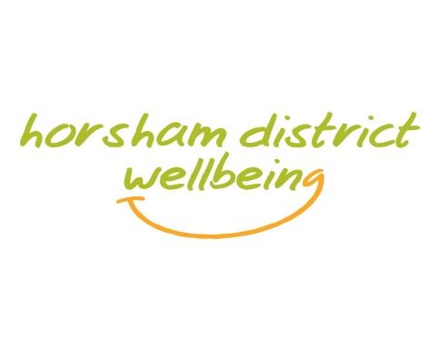
My name is Sam Wright and I am the Alcohol Advisor for the Horsham District.
This service provides a series of one to one sessions to support people who may have been identified by a health professional as drinking at an increased high level or the individual themselves believe they are drinking at a problematic level and either want to cut down or stop drinking altogether to enjoy a healthier lifestyle.
This is a confidential non-judgmental service with no group work involved and people are not expected to stop drinking completely unless they want to.
Throughout the course of 6-8 sessions we encourage people to make positive changes in the here and now rather than focussing on things that can’t be changed in the past. This approach is based on an ‘Extended Brief Intervention structure’ using motivational interviewing techniques. The sessions can work well alongside traditional counselling and medical treatments if the client wishes.
The sessions last approximately 45 minutes and we are pleased to be able to offer telephone support and video call sessions depending on what the client feels comfortable with. Best of all the sessions are free and you can attend just one or up to eight of the sessions offered.
We will monitor your progress through a mixture of self-assessment and questionnaires during the beginning, middle and end points of our contact.
We encourage the use of tools such as Drinks Diaries, measuring cups and apps as a way of monitoring how you’re doing.
We discuss tips to reduce alcohol consumption, triggers as to why you may be drinking more than the governments recommended weekly amount and benefits to your mental and physical health by cutting back.
We can offer health information, useful resources, advice and referrals or signposting to other services as required.
Once the sessions are finished, we will contact you in 3 months to check on your progress and get some feedback from you on how we did and if there was anything we could have done better.
Thank you for taking the time to watch this video. If you feel drink is sneaking up on you and you could benefit from this service, you can refer yourself by giving us a call on 01403 215111, sending us an email at info@horshamdistrictwellbeing.org.uk or by completing our online referral form on the contact us page on our website www.horshamdistrictwellbeing.org.uk

